5. september – 31. oktober 2016

Sodeluj na fotografskem natečaju

FOTOZGODBA NAŠE SOSESKE

Humana mesta: izzivanje merila mesta

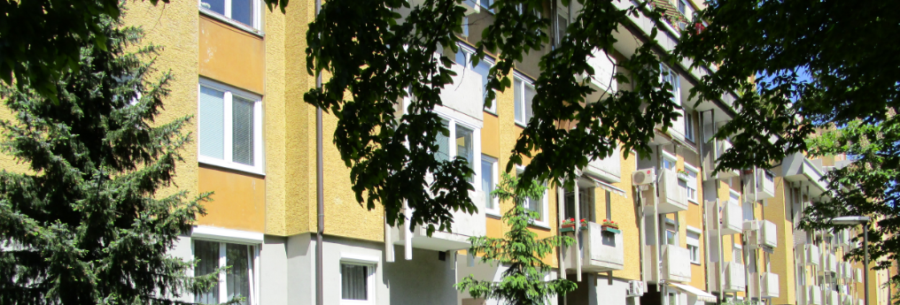
© arhiv Urbanističnega inštituta RS

Vabljeni ste, da v fotografski objektiv ali v objektiv pametnega telefona ujamete podobo iz vaših/naših velikih stanovanjskih sosesk, saj bomo tako ustvarili skupni foto album oziroma tematsko zbirko fotografij današnjega stanja sosesk v Sloveniji in drugod.
Fotografije s podnapisi oddajte na internetni strani humancities.uirs.si, kjer se registrirate in za vsako fotografijo izberete eno od petih kategorij:
a.) najprijetnejši prostor moje soseske
b.) poklici v moji soseski
c.) moj sosed
d.) meje moje soseske
e.) skupne vrednote moje soseske
Fotonatečaj je odprt od 5. septembra do 31. oktobra 2016.
Mednarodna režija bo za vsako kategorijo izbrala tri fotografije, ki bodo natisnjene kot razglednice s predstavitvijo avtorjevega pogleda na sosesko. Predstavljene bodo ob zaprtju razstave Soseske in ulice v Muzeju za arhitekturo in oblikovanje (MAO) ter spomladi 2017 na potujoči razstavi v okviru projekta Humana mesta.

Natečaj organizira Urbanistični inštitut Republike Slovenije (UIRS) v okviru mednarodnega projekta Humana mesta: izzivanje merila mesta (Ustvarjalna Evropa 2014–2020) in v sodelovanju z Muzejem za arhitekturo in oblikovanje (MAO) ter lokalno iniciativo Skupaj na ploščad!.

5 September – 31 October 2016

Take part in photo contest

PHOTO-STORY OF OUR NEIGHBOURHOOD

Human Cities: Challenging the City Scale

© archive Urban Planning Institute of the Republic of Slovenia

You are invited to catch the image of yours/ours residential neighbourhoods through a photo camera or a camera on a mobile phone, an thus contribute to the creation of a common photo album of the current state of the art in the neighbourhoods.
Submit the photos and their subtitles on the web page humancities.uirs.si, where you can register and place your photo within one of the following categories:
a.) most pleasant place in my neighbourhood
b.) professions in my neighbourhood
c.) my neighbour
d.) borders of my neighbourhood
e.) shared values in my neighbourhood
Photo contest runs from 5th of September to 31st of October 2016.
An international jury will select three photos from each category, which will be printed as postcards with the presentation of author's view of a neighbourhood. They will be presented at the closure of the exibition Streets and Neighbourhoods in the Museum of Architecture and Design in Ljubljana (MAO) and in spring 2017 at the travelling exibition of Human Cities project.
The contest is organized by the Urban Planning Institute of the Republic of Slovenia (UIRS) within the framework of the international project Human Cities: Challenging the city scale (Creative Europe 2014–2020) in cooperation with Museum of Architecture and Design (MAO) and local initiative Skupaj na ploščad! / Together to the platform!.

